Blackbox AI for Coding Assistance
Iftikhar Ahmed
Introduction
Blackbox AI is an AI-powered coding assistant designed to help programmers generate, understand, and improve code more efficiently. It is mainly used by developers and students for coding support, debugging, code generation, and software development tasks. The AI can convert text prompts into working code snippets in multiple programming languages. This tool is useful because it saves development time and helps users learn programming concepts faster. People may need this AI for web development, software projects, academic assignments, and rapid prototyping.
Prompt
Input Prompt Given to the AI:
Create a simple e-commerce demo website using HTML, CSS, and JavaScript.
Requirements:
- A clean homepage with a navigation bar (Home, Products, Cart)
- A product section displaying at least 3 products (name, price, button)
- Add "Add to Cart" buttons for each product
- A cart section that shows selected items
- Simple responsive design
- Use modern styling with cards, shadows, and spacing
- Keep the code beginner-friendly and well organized
- No backend needed, only frontend”
Optional Inputs (if applicable):
- Programming Languages: HTML, CSS, JavaScript
- Project Type: Frontend Demo Project
- Design Preference: Responsive and Modern
- Code Style: Organized and Beginner-Friendly
Output
The AI generated the code for a simple e-commerce demo website using HTML, CSS, and JavaScript. The project included a responsive navigation bar, product cards, add-to-cart buttons, and a dynamic cart section. It also used modern styling techniques such as shadows, spacing, and responsive layouts. The generated code was well organized and easy to understand for beginners.
Describe Your Output
The output successfully met all the requirements mentioned in the prompt. The generated website design was clean and responsive across different screen sizes. The JavaScript functionality allowed products to be added dynamically to the cart section. The code structure was simple and readable, making it suitable for beginners learning frontend development. Overall, the AI produced a functional and visually appealing demo project.
Prompt Engineering
The following methods can improve prompts and produce better coding outputs from Blackbox AI:
- Clearly specify the programming language and technologies required.
- Mention the difficulty level such as beginner, intermediate, or advanced.
- Include detailed design requirements like responsiveness, animations, or color themes.
- Request comments inside the code for easier understanding.
- Specify whether the code should be contained in one file or separated into multiple files.
- Mention any restrictions such as “no frameworks” or “frontend only.”
- Use structured bullet points for clearer instructions.
- Refine the prompt after reviewing the first generated output.
- Ask for optimized and reusable code practices when needed.
- Specify whether external libraries or APIs are allowed.

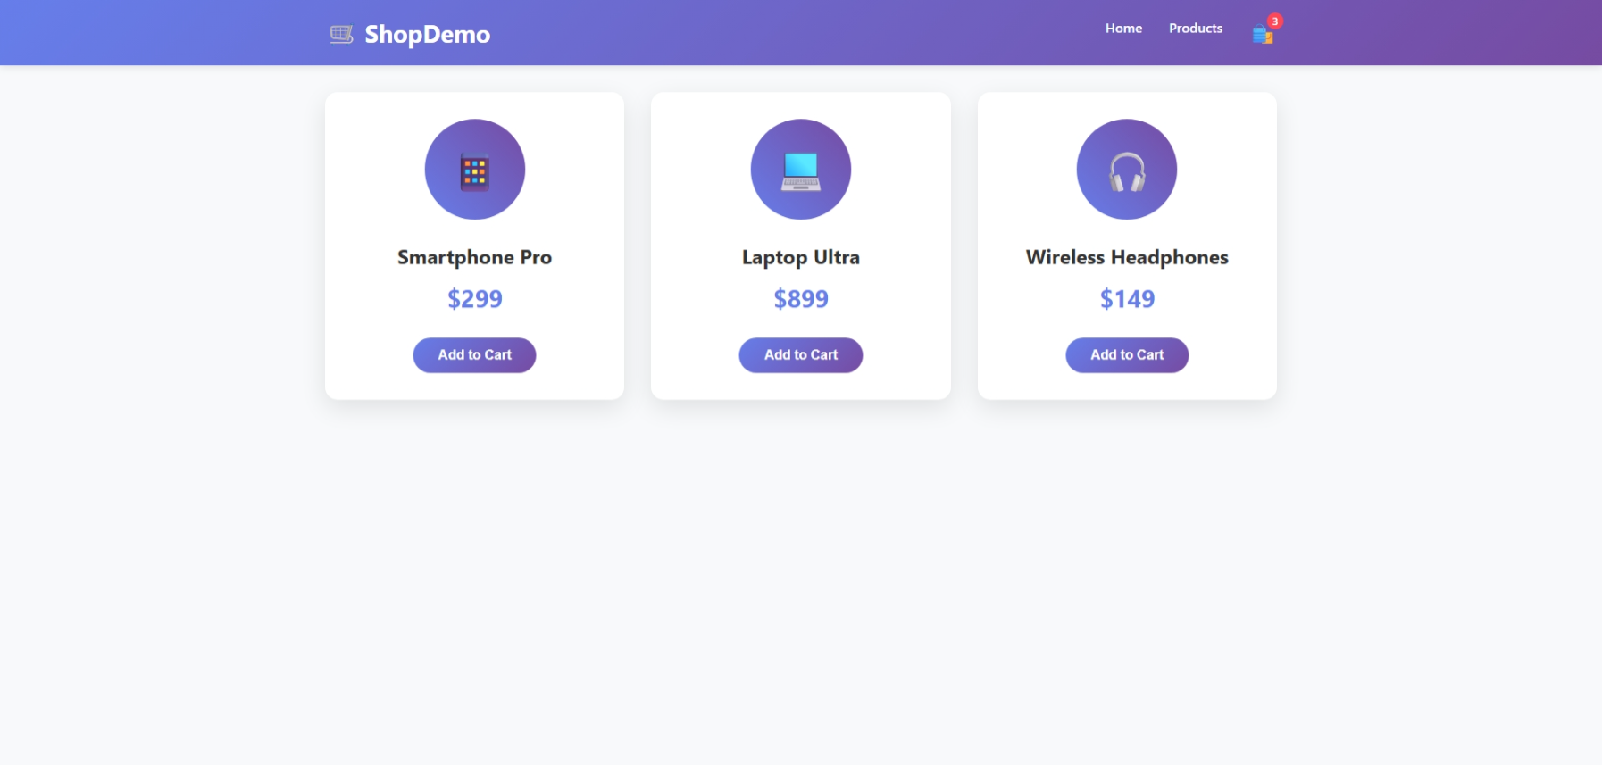

Conclusion
Blackbox AI is a highly useful coding assistant for developers and students who need fast and organized code generation. Compared to tools like GitHub Copilot and ChatGPT, Blackbox AI focuses strongly on coding-related tasks and quick code suggestions. However, some competing AI tools may provide more detailed explanations and debugging assistance. Blackbox AI performs especially well for rapid prototyping and beginner-friendly coding projects. Overall, it is an efficient tool for improving programming productivity and learning software development.

